Since 1999, a persistent feature of American public education is the school shooting; such events captivate the national media discourse, though often only for brief periods of time (citation). Much research has focused on theoretical causes of such incidents, with focuses on media and popular culture (e.g., violent video games and music), the availability of guns, bullying in schools, and adolescent mental health. This research and discourse has operated on the assumption that identifying the causes of such incidents can allow schools and policymakers to reduce their frequency. Since the shooting at Columbine High School in April of 1999, the frequency of such shootings has remained roughly consistent, with about 15 such incidents per year. In fact, at the time of writing of this literature review in there have already reached a larger-than-average number of shootings, indicating that 2018 may be an outlier year for school shootings. The data suggest that rather than being an increasing trend, as perhaps portrayed in the media, nor a trend abated by 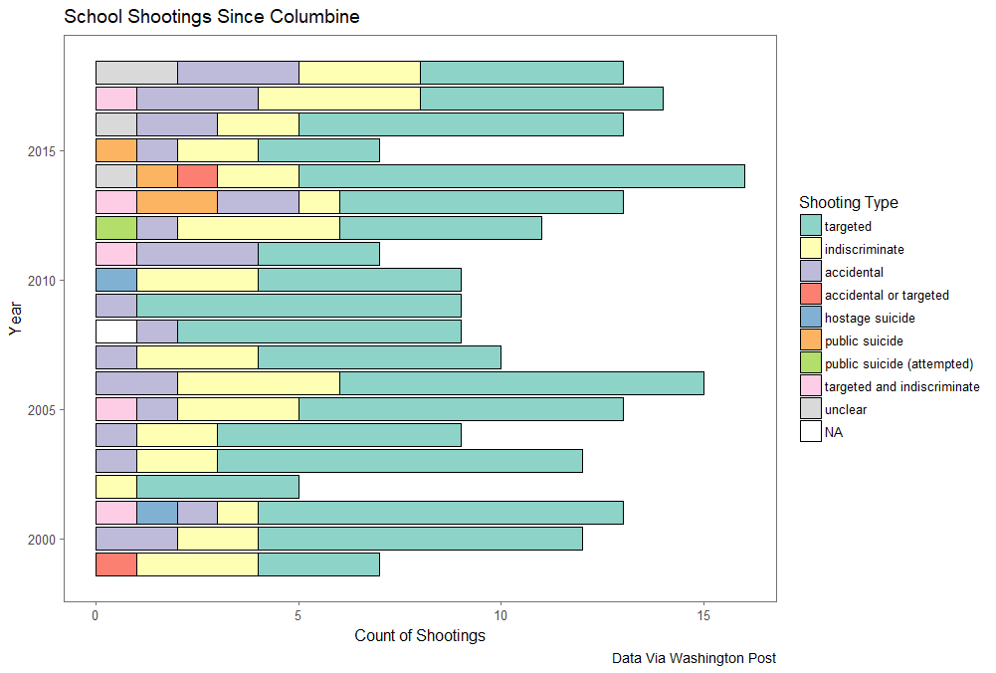improvements in public policy, school shootings are a consistent fact of life in American PK-12 education which must be considered on those terms. If they cannot be reduced in number, policy must be created around mitigating the effects of such incidents, particularly within schools themselves.

The data suggest that such shootings happen at all grade levels, with elementary schools represented (e.g. Buell Elementary School in 2000) as well as shootings in tertiary education such as the Virginia Tech incident in April, 2007.